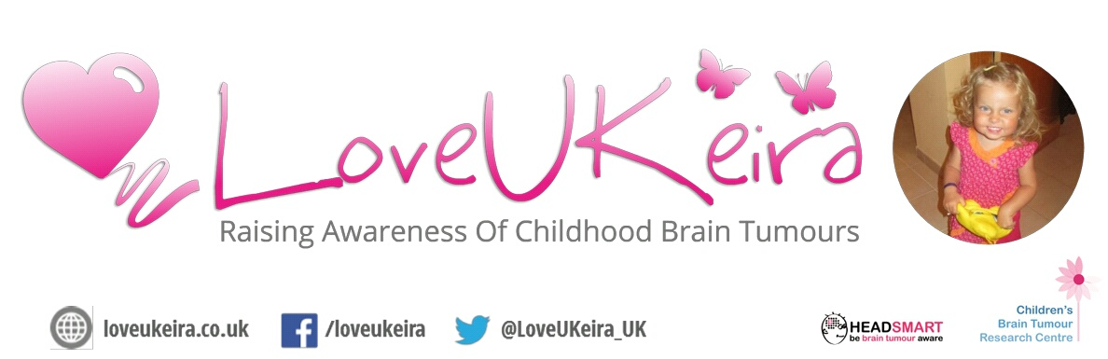
LoveUKeira
Tim & Kirsty Lee (Founders)
Horley, Surrey.
info@loveukeira.co.uk
07775 832060
www.loveukeira.co.uk

15/06/15

LoveUKeira Tractor Road Trip 2015 – Press Release

Horley residents Tim and Kirsty Lee’s beautiful daughter Keira, was diagnosed with a brain tumour on the 28th November 2013 at 2 years old, and died just 1 week later on December 5th following surgery to partially remove the tumour. “I’ve tried many times to put into words how this has affected me, my wife, Keira’s siblings and generations of our family – but I simply can’t explain the absolute horror we have, and continue to go through”
“And that is precisely why we have created LoveUKeira, to try to spare other children and families from the pain and heartbreak that we know first-hand. In partnership with The Children’s Brain Tumour Research Centre at The University of Nottingham, The Brain Tumour Charity and their joint campaign HeadSmart, we are trying to do our best to raise awareness and vital research funding.
On the 10th of August 2015, 3 members of the LoveUKeira team will set off on an epic 700 mile journey on 3 vintage tractors with a combined age of over 160 years (the tractors, not the team!). After months of preparation and restoration we will have a 1961 Fordson Super Major and two 1958 Fordson Dextas towing 3 beautiful vintage showman’s wagons from the 1920’s era. One of our Dextas has been lovingly painted stunning pink in Keira’s honour and is attracting a lot of attention! Starting in Crawley, West Sussex the team will spend 3 weeks on the road across the South of England to raise awareness and vital funds for research, hosting several evening events and displaying their magnificent machines at 3 popular country shows. Further details of the event can be found at www.loveukeira.co.uk and the team can be sponsored at www.justgiving.com/loveukeiraroadtrip or by texting KEIR70 £3 to 70070 (or any amount between £1 and £10).

The Road Trip Team
Team leader Shane Portman was born and raised on and around farms in Devon and Dorset. Shane’s Grandad was a ploughman after leaving the army in the early fifties. He started working with horses but eventually moved on to tractors, his first being a 1948 Fordson E27N. He continued to work up until the late 1970s. Shane’s Father was a dairyman and at the age of 13 the family moved to Surrey, where they have a small holding of around 25 acres and keep chickens and a few sheep. Shane and his family, including uncles and cousins have around 20 vintage tractors and implements including his Grandad’s Fordson E27N, his Massey Harris 745 and his pride and joy, a 1932 Aveling & Porter steam roller. Every year Shane, his family and friends run their magnificent machines out on the remaining 130 acres of the farm.
Shane is accompanied on the road trip by his wife Donna (who insisted on the bright pink paint job for her tractor in Keira’s honour!) and his good friend, Patrick Holden, a contract tractor driver.

It is a little known fact that brain tumours are the most common cause of cancer death in our children. 10 children or young people are diagnosed EVERY week in the U.K. alone. 25% will die (that’s 1 every 3 days) and of the survivors, around 60% will suffer significant ongoing disabilities.
Awareness really is the key here. Awareness of the signs and symptoms for parents but also importantly for GPs and other front line medical professionals. This will reduce average times to diagnosis, meaning earlier treatment and a better chance of a good outcome. Again, not widely known, but the incidence rate for childhood brain tumours is actually higher than bacterial meningitis - an equally devastating illness where awareness has had a hugely positive impact.
Awareness also helps to generate charitable donations for funding into research to improve treatments and one day, find a cure. Despite killing more people under 40 than ANY other cancer – funding for brain tumour research represents less than 2% of total cancer research spending in this country.”
Thank you
Tim & Kirsty Lee, LoveUKeira Founders

